Spring Newsletter 2023

Welcome
We would like to welcome new lot owners to The Peaks. A special welcome to Mariann Dunn who is completing the new construction as you enter the neighborhood.
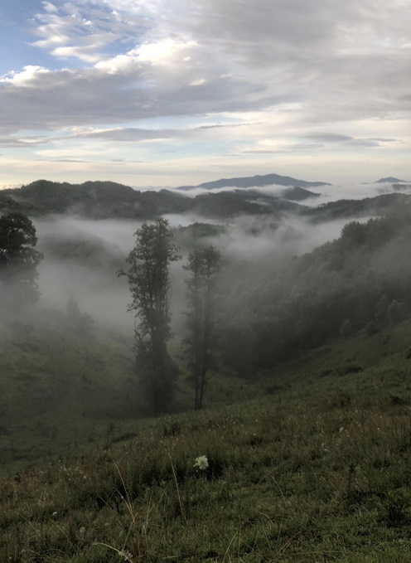
Announcement We invite all lot owners and residents to join us at The Annual Peaks POA meeting. It will be held on Saturday, June 24th at 2:00pm at the Ashe County Library. An invite with information for the Peaks Annual meeting will be included in your annual dues invoice. If you are not able to attend, please send in your ballots and/or proxy. This is important to make certain we have a quorum at the meeting. The quorum provides for a productive meeting. A zoom link will be provided as we get closer to the The Peaks Annual meeting.

Springs & Creeks

The Peaks POA Website
We have established a new website for The Peaks neighborhood POA. We encourage you to use it for reference and find it to be a convenient place to find updates on The Peaks neighborhood.
Please visit thepeakspoa.org and sign – up for email reminders, newsletters and more.
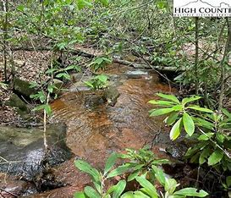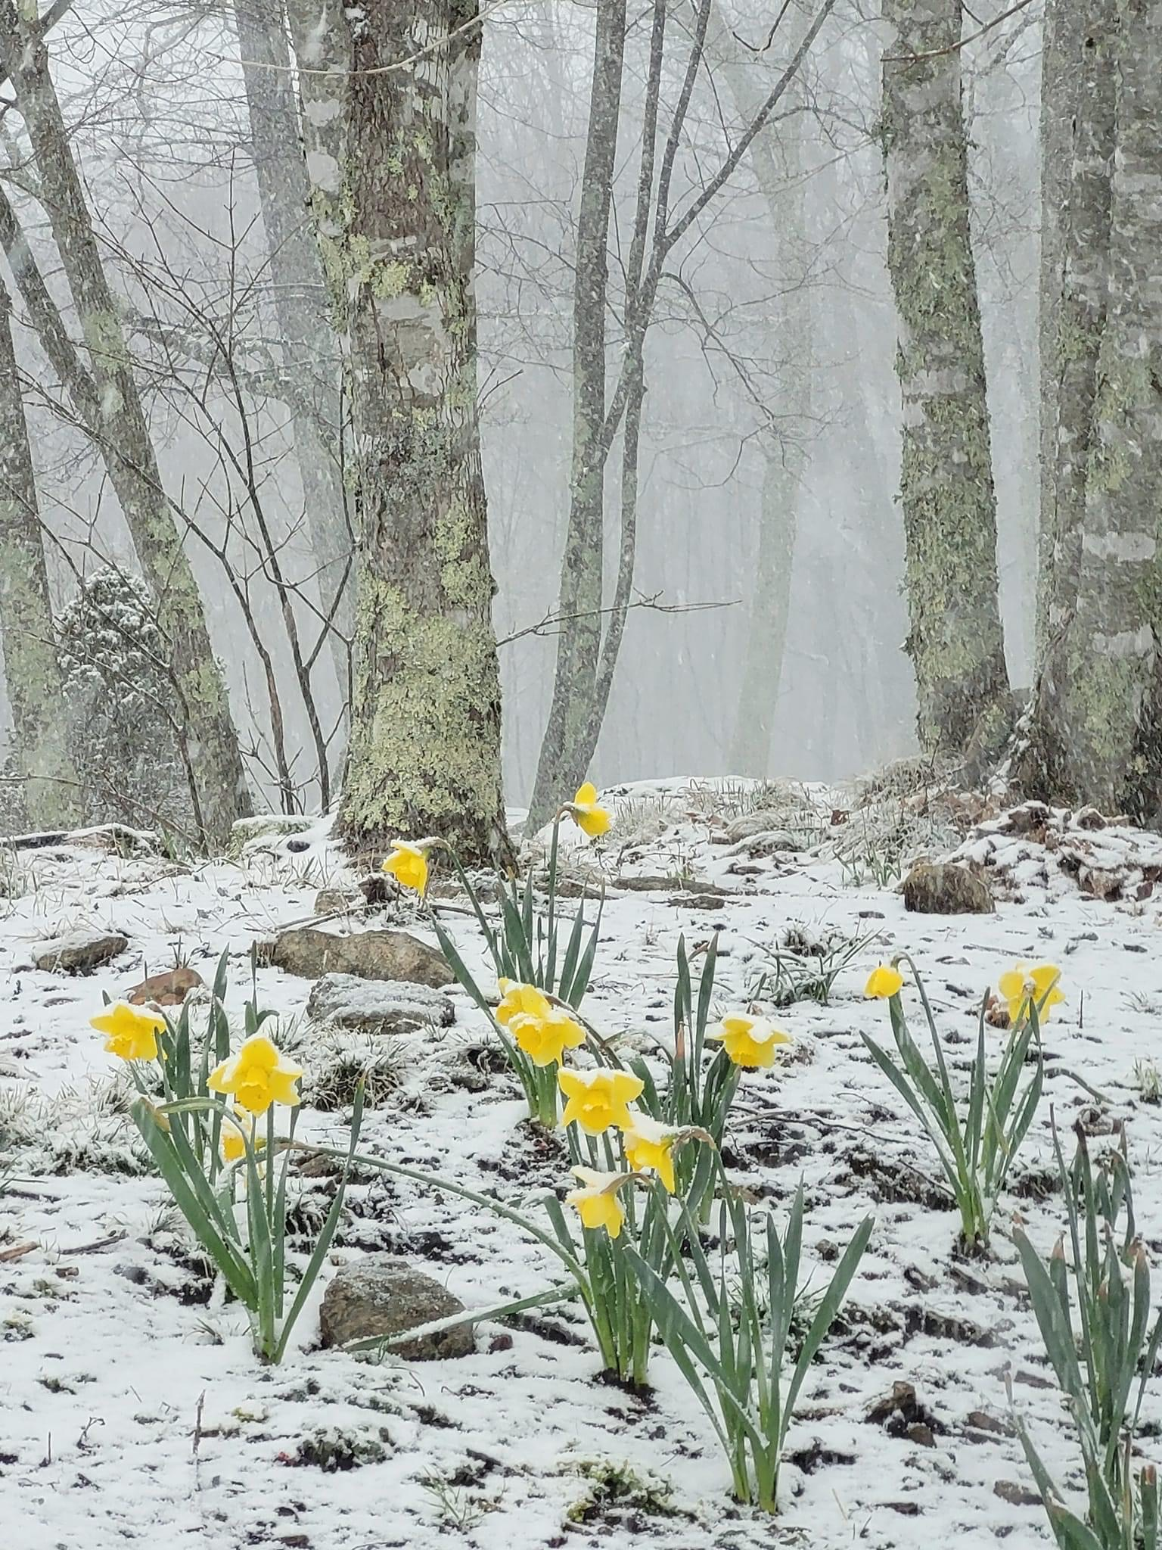
The springs and creeks are flowing from an abundance of wintry mix and rainfall this winter. However, things are slowly waking up with the evidence of daffodils and forsythia popping though the frozen ground. The beauty of springtime everywhere in the Peaks and throughout the High Country.
Be sure to take in the beauty of the native mountain laurels and rhododendrons in The Peaks. Wildflowers add to the spring beauty and give more options for the bees. The POA board and beautification committee have ordered some wildflower seeds. It is a lovely variety of blue flax, black – eyed susan, cone flower, daisies etc. If you would like to assist in the beautification of the neighborhood by planting wildflowers along your property line towards the road…please let us know. We will be sure you get a bag of seeds in the coming weeks.
Reminders: *All lot owners planning to build should submit plans to the architectural committee for approval
*Speed limit inside the Peaks neighborhood is 15mph
*Anyone driving an atv or tractor should have a valid driver’s license
Wishing everyone a happy spring. Get out there and enjoy.
We hope to see you at the Peaks Annual Meeting.
Peaks POA Board of Directors

CONTACT US:
Email: peakspoa@gmail.com
P.O.Box 110
Jefferson, NC 28640

